Devin Lim

DATA 5322 Written Homework 1: Decision Trees

April 15, 2024

Correlates of Alcohol Consumption Among Youth

## Abstract

Youth substance use can lead to various short-term problems and may “develop into lifelong issues such as substance dependence, chronic health problems, and social and financial consequences”1. The National Survey on Drug Use and Health (NSDUH), which started in 1971 and became an annual survey in 1990, “is the primary nationally representative source of annual estimates of drug use and mental illness … in the United States”2. Using the data from 2020 NSDUH, this paper aims to examine the top factors that are correlated with youth (aged 12 to 17) alcohol use by utilizing various machine learning methods. We found that the top factors correlated with underaged alcohol use are multifaceted, and that they tend to follow a certain theme – violence, peer group, and socioeconomic.

## Introduction

Alcohol is our youth’s drug of choice; it is consumed more frequently than either tobacco or marijuana. Youth also binge drink more often compared to adults – 90% of alcoholic beverages consumed by youth are consumed during acts of binge drinking. This behavior is linked to increased risk of injuries, death, physical and sexual assault, learning difficulties, and alcohol problems later in life.3 As such, it is crucial to understand the factors that are correlated with youth drinking so that it may inform our policies and approach to harm reduction.

The dataset used in this analysis is a subset of the 2020 NSDUH4 that has been processed by Dr. Mendible5 to include only youth data ages 12 to 17 consisting 79 out of the 2,890 variables. The variables include substance usage statistics for alcohol, marijuana, and cigarettes along with demographic data such as household income, peer influence, and parental involvement.

Various machine learning algorithms and training approaches are compared and utilized to uncover factors most correlated to youth drinking. More specifically, we analyze

factors related to ‘iralcage’ (the age a youth first consumed alcohol, ‘alcflag’ (whether a youth has ever consumed alcohol), and ‘alcydays’ (the number of days a youth has consumed alcohol within the past year). These factors are then further examined to provide us with usable insights. Background information on the data preparation process and machine learning methods is provided below.

## Background

### Null Model

The Null Model serves as a baseline in both regression and classification problems. In regression, it always predicts the mean of the response variable. In classification, it always predicts the most frequent class. It is important to compare the models we build against the Null Model to ensure that our models provide real benefits over the simplest possible baseline.

### Ordinary Least Squares

Ordinary Least Squares is the earliest form of linear regression6. This method aims to create a best fit line such that the distance between the points and the line (known as the residuals) is minimized. The best fit line is defined by a set of constants acting as weights to the predictors and an irreducible error. Requires many assumptions to be met about the data, such as the linearity between predictor and response and no collinearity between predictors.

$$\hat{y}=β_{0}+β_{1}x_{1}+β_{2}x_{2}+…+β_{p}x_{p} + ϵ$$

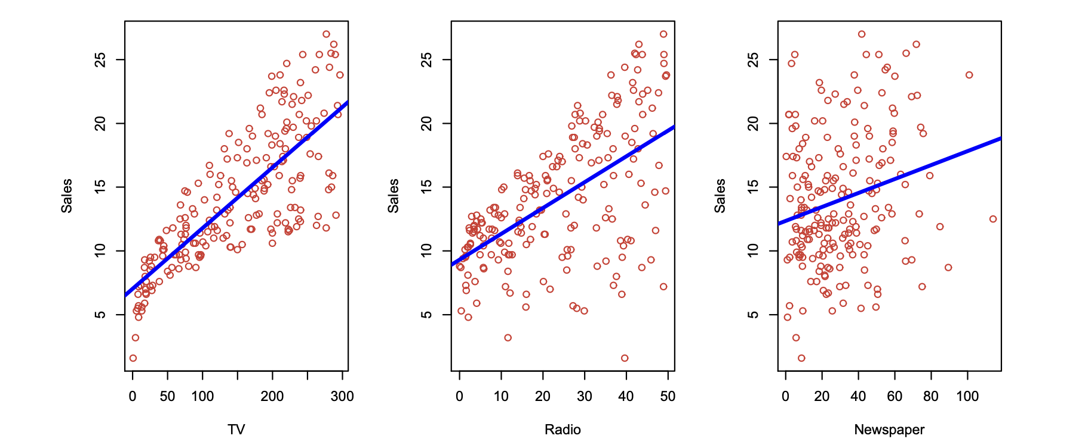Figure 1. Ordinary Least Squares Regression.6

### Lasso

The Lasso model adds a penalty term to Ordinary Least Squares. This penalty term is the sum of the absolute values of the coefficients multiplied by the tuning parameter λ. This encourages the model to shrink coefficients as much as possible, often to zero, which improves model interpretability (it performs variable selection). Unlike Ordinary Least Squares, Lasso can handle collinearity between predictors.

$$\sum_{i=1}^{n}{{\left(y_{i}-β_{0}-\sum_{j=i}^{p}{β_{j}x_{ij}}\right)}^{2}}+λ\sum_{j=1}^{p}{\left|β_{j}\right|}=RSS+λ\sum_{j=1}^{p}{\left|β_{j}\right|}$$

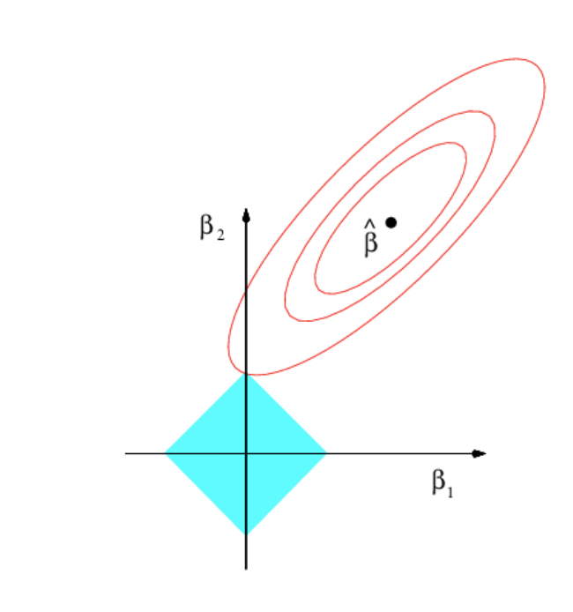

Figure 2. Lasso Regression.6

### Random Forest

Random Forest is an ensemble learning method which combines (aggregates) predictions from multiple decision trees created through bootstrap sampling independently (trees can be trained in parallel). A decision tree is used in both regression and classification problems and is created by recursively splitting data following a greedy approach. Random Forest modifies this by randomly selecting a subset of features at every split, making it more suitable to handle non-linear, high-dimensional data while still providing some interpretability. It is also robust to overfitting due to the averaging effect. However, it can be computationally expensive to train.

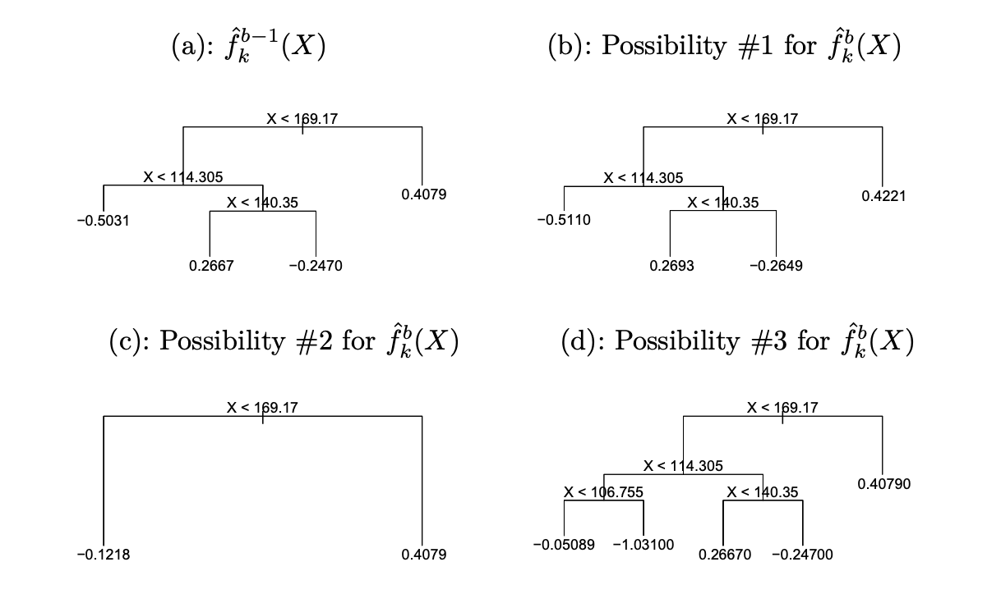

Figure 3. Ensemble Learning Method.6

### Gradient Boost

Similar to Random Forest tree where it aggregates results from multiple decision trees, but each tree is trained sequentially by correcting mistakes made by previous models. It may achieve better results, but it is more sensitive to overtraining and more computationally expensive.

### Methodology

### Data Preparation

Each variable’s value in the NSDUH data is encoded, with their meanings provided in a Codebook2. Some variables are numerical with certain values reserved for special meanings (see Figure 3), while others are a mix of categorical and special meanings. Furthermore, some variables were numerical, some were ordinal, and some were nominal. Due to this, extensive data cleanup was required.   
  
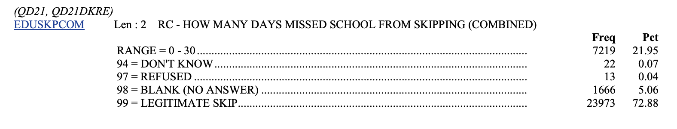

Figure 4. Ensemble Learning Method.2

The steps are as follows:

1. Split the variables into “substance” columns and “demographic” columns, treating “substance” as a pool of response variables to choose from and “demographic” as all our predictor variables.
2. Define a list containing values to be treated as a “missing value” (such as 94, 97, 98, and 99 for ‘EDUSKPCOM’ as shown above), so that they may be imputed with the other missing values.
3. Separate the variables into different categories such as numerical / ordinal / nominal. This is necessary because when dummies are being created, you must not treat an ordinal variable as a binary variable because that implies that each category are independent to one another and will cause misinterpretation / wrong results.
4. Finally, manual handling of special cases such as ‘EDUSCHLGO’ whose value of 11 was grouped with 1 (11 is “Yes” with some uncertainty) and ‘EDUSCHGRD2’ which was removed from being a predictor for ‘iralcage’ as it is essentially a proxy for age where the response variable is highly correlated to age.

The imputation process uses IterativeImputer() with a RandomForestClassifier() estimator impute missing values for each predictor using all other predictor. After imputation is completed, some columns were one-hot encoded (as most of the data are already encoded ordinally or are binary).

### Modeling

For each response variable analyzed (‘iralcage’, ‘alcflag’, and ‘alcydays’, we trained a Random Forest model and compared it with a Null Model plus at least 1 other appropriate model (such as Lasso and Gradient Boosting). Every model except for the Null Model was trained with all predictors and tuned with Grid Search 10-fold Cross Validation, either sequentially with 1 hyperparameter at a time or also exhaustively with multiple hyperparameters at a time. All models were trained and tested on a 70-30 split dataset.

## Results

### ‘iralcage’ - The age a youth first consumed alcohol

‘iralcage’ is a numerical column with a possible value of 1-66 and 991 (indicating never used alcohol). We trained various cross-validated models against ‘iralcage’ using all demographic columns and obtained a result of:

|  |  |
| --- | --- |
| Model | Test MSE |
| Random Forest Regression | 5.4 |
| Null Model | 5.91 |
| Ordinary Least Squares | 5.44 |
| Lasso Model | 5.36 |

Based on the above, we opted for the Lasso Model for ease of interpretability, as it shrank most of the coefficients to 0 and left us with only a handful to look from and allows for negative coefficient, which tells us the direction of the correlation.

Figure 5. ‘iralcage’ most important features.

The top 5 correlates are:

|  |  |  |
| --- | --- | --- |
| Predictor | Description | Coefficient |
| YOATTAK2 | Youth attacked with intent to seriously harm | 0.623587 |
| YOFIGHT2 | Youth had serious fight at school/work | 0.623298 |
| STNDALC | Youth’s knowledge of other students’ drinking | -0.593558 |
| YOGRPFT2 | Youth fought with group vs other group | 0.475455 |
| NEWRACE2_6 | Youth of mixed race (non-hispanic) | -0.354749 |

The first four predictors are binary variables, where 1 is generally a negative (such as youth **has** attacked with intent to seriously harm) and 2 is generally a positive (such as none/few of other students drink alcohol). Since ‘iralcage’ corresponds to age, a positive correlation means that youth who are not involved in violent acts can be expected to have started drinking later in life. The 5th predictor must be treated with caution. It is likely that there are underlying socioeconomic, cultural, or environmental factors associated with this correlation, and we would be good to remember that correlation does not equal causation.

### ‘alcflag’ - Whether a youth has ever consumed alcohol

‘alcflag’ is a binary categorical variable with a possible value of 0 (indicating never used) and 1 (indicating ever used). We trained various cross-validated models against ‘alcflag’ using all demographic columns and obtained a result of:

|  |  |
| --- | --- |
| Model | Accuracy Score |
| Random Forest Classifier | 0.8267 |
| Null Model | 0.76 |
| Gradient Boosting Classifier | 0.8261 |

Based on the above, we opted for the Random Forest Classifier for its faster computation and better accuracy. This classifier’s parameters are ‘n_estimators=175’ (tree size) and ‘max_features=10’ (feature split size). The top 5 correlates are:

|  |  |  |
| --- | --- | --- |
| Predictor | Description | Importance |
| EDUSCHGRD2 | Youth’s grade in school | 0.065901 |
| STNDALC | Youth’s knowledge of other students’ drinking | 0.058377 |
| YFLMJMO | Youth’s feelings about peers using marijuana monthly | 0.051380 |
| FRDMEVR2 | How youth’s close friends feel about the youth trying marijuana | 0.041730 |
| FRDMJMON | How youth’s close friends feel about the youth using marijuana monthly | 0.032699 |

The first predictor seems self-evident – the older you are the more likely you have tried alcohol. However, the other four predictors are all related to the youth’s peer group. This shows that a youth’s first-time drinking underaged is heavily influenced by their peer group. To examine the direction of the predictors in a large tree, we can try to make a smaller tree:

Figure 6. ‘alcflag’ Decision Tree.

Here we can observe some general trends:

* The higher the youth’s grade in school is, the more likely they are to have started drinking (and be older).
* Since peer group questions are structured as 1 being “disapprove”, we can see that a youth is less likely to start drinking if their peer group disapproves of it.

For example, if we trace only the left path until its terminal node, it would satisfy conditions where although most or all of the youth’s friends drink alcoholic beverages, if the youth’s peer group disagree with monthly marijuana use, the youth is now very unlikely to start drinking underaged (1 out of 6 terminal nodes).

### ‘alcydays’ - Number of days a youth has consumed alcohol within the past year

‘alcydays’ is a multi-class categorical variable with a possible value of 1 (1-11 days), 2 (12-49 days), 3 (50-99 days), 4 (100-299 days), 5 (300-365 days), and 6 (no past year use, though this is removed from the data). We trained various cross-validated models against ‘alcydays’ using all demographic columns and obtained a result of:

|  |  |
| --- | --- |
| Model | Accuracy Score |
| Random Forest Classifier | 0.6079 |
| Null Model | 0.6049 |
| Gradient Boosting Classifier | 0.6049 |

Based on the above, we opted for the Random Forest Classifier for its faster computation and better accuracy. This classifier’s parameters are ‘n_estimators=150 (tree size) and ‘max_features=1’ (feature split size). The top 5 correlates are:

|  |  |  |
| --- | --- | --- |
| Predictor | Description | Importance |
| EDUSCHGRD2 | Youth’s grade in school | 0.065901 |
| HEALTH2 | Youth’s health condition | 0.058377 |
| COUTYP4 | Youth’s county’s metro/nonmetro status | 0.051380 |
| INCOME | Youth’s total family income | 0.041730 |
| STNDALC | Youth’s knowledge of other students’ drinking | 0.032699 |

Unlike the response variable from previous section, chronic drinking is less (though still) influenced by peer group and more influenced by socioeconomic factors such as income and the county that the youth reside in.

## Discussion

This analysis shows that the factors that correlate with underage drinking are multi-faceted. The best predictors for a youth’s age at the time of first drink are mostly related to violence, while the best predictors for a youth’s having ever had a drink are mostly related to their peer group. And perhaps most concerning is that the best predictors for chronic drinking in youths are socioeconomic factors like income and county.

Future analysis may be useful to further uncover trends between the demographic columns and the substance use columns. There are likely to be similarities between, for example, factors that cause youth to try alcohol and to try marijuana. Further analysis should also focus on uncovering the underlying causes that affect one racial group disproportionately.

## References

1. Substance use/misuse [Internet]. [cited 2024 Apr 15]. Available from: https://youth.gov/youth-topics/substance-abuse
2. 2020 NATIONAL SURVEY ON DRUG USE AND HEALTH [Internet]. [cited 2024 Apr 16]. Available from: https://www.datafiles.samhsa.gov/sites/default/files/field-uploads-protected/studies/NSDUH-2020/NSDUH-2020-datasets/NSDUH-2020-DS0001/NSDUH-2020-DS0001-info/NSDUH-2020-DS0001-info-codebook.pdf
3. Get the facts about underage drinking [Internet]. U.S. Department of Health and Human Services; [cited 2024 Apr 15]. Available from: https://www.niaaa.nih.gov/publications/brochures-and-fact-sheets/underage-drinking
4. National Survey on Drug Use and Health (NSDUH) population data [Internet]. [cited 2024 Apr 15]. Available from: https://www.datafiles.samhsa.gov:443/dataset/national-survey-drug-use-and-health-2020-nsduh-2020-ds0001
5. Mendible A. Youth Data [Internet]. [cited 2024 Apr 15]. Available from: https://github.com/mendible/5322/blob/main/Homework%201/youth_data.csv
6. James G, Witten D, Hastie T, Tibshirani R, Taylor J. An introduction to statistical learning: With applications in Python. Cham, Switzerland: Springer; 2023.